"The undersigned author/s transfer(s) to Health SA Gesondheid (published by UJ) all copyright of which he/she is the owner in respect of the article entitled “A comparative study of the effects of methamphetamine on memory in existing and recovering addicts from a South African population”, in the event that the work is published. In the event that the copyright subsists in someone other than the author, she/he warrants that copyright in the article may be so transferred. The undersigned author/s warrant(s) that the article is original, is not under consideration by another journal, and has not been previously published".

Signed:

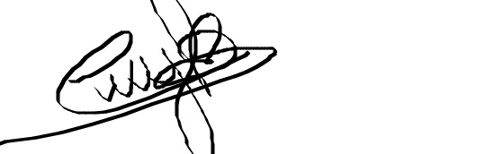
____________________________________
Cindy van Wyk (M.A. Psychology cum laude)

“I have participated sufficiently in the conception and design of this work, the data analysis (when applicable), and the writing of this article to take public responsibility for it. I have reviewed the final version of the article and approve it for submission for possible publication”.

Signed:

____________________________________
Cindy van Wyk (M.A. Psychology cum laude)



